Assigment No 10

1) Write a query that produces all pairs of
salespeople who are living in the same city.Exclude combinationsofsalespeoplewith
themselves as well as duplicate rows with the
order reversed.
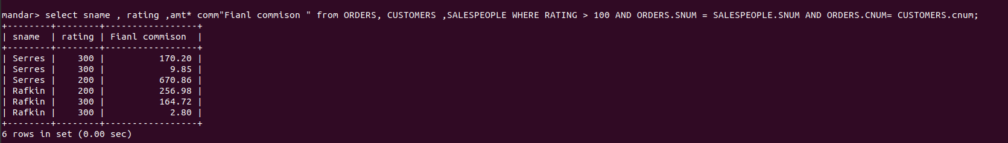

2) Write a query that produces the names and
cities of all customers with the same rating as
Hoffman.

